- i. What fraction of employees that left the company are women? Ans: 0.367
ii.Are men? Ans: 0.633
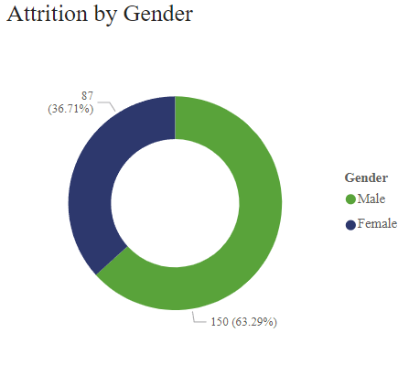

- What effect does your marital status have on income? Not much but it seems married people have higher monthly income.
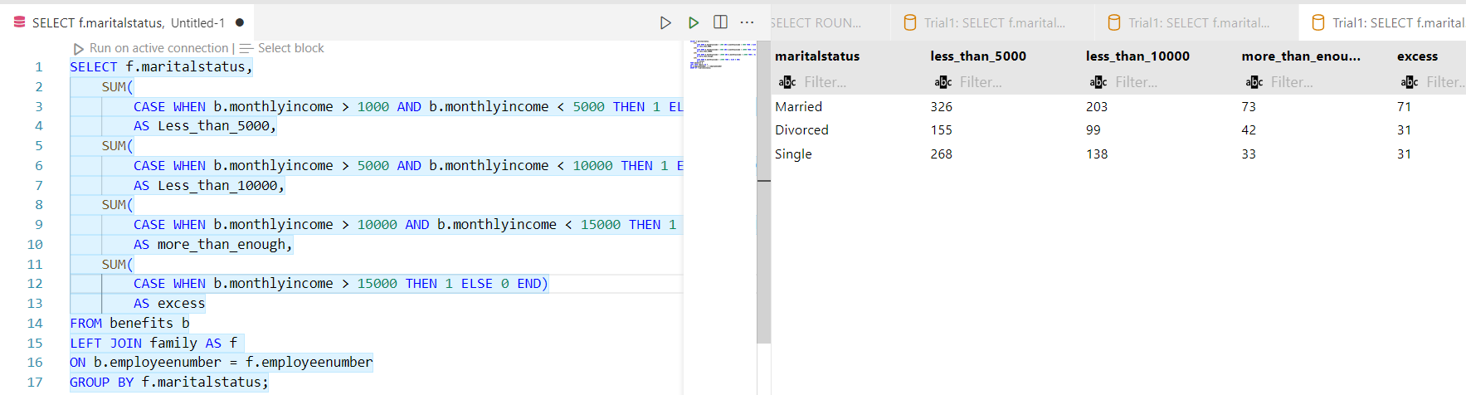
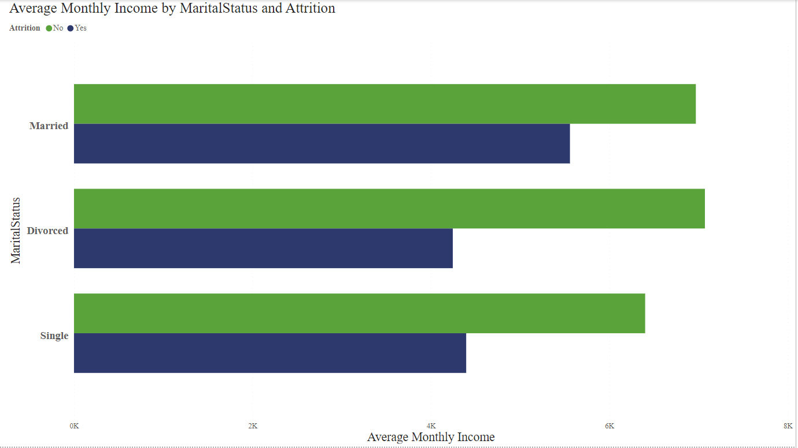

- Is there a correlation between the number of years worked and the last promotion?
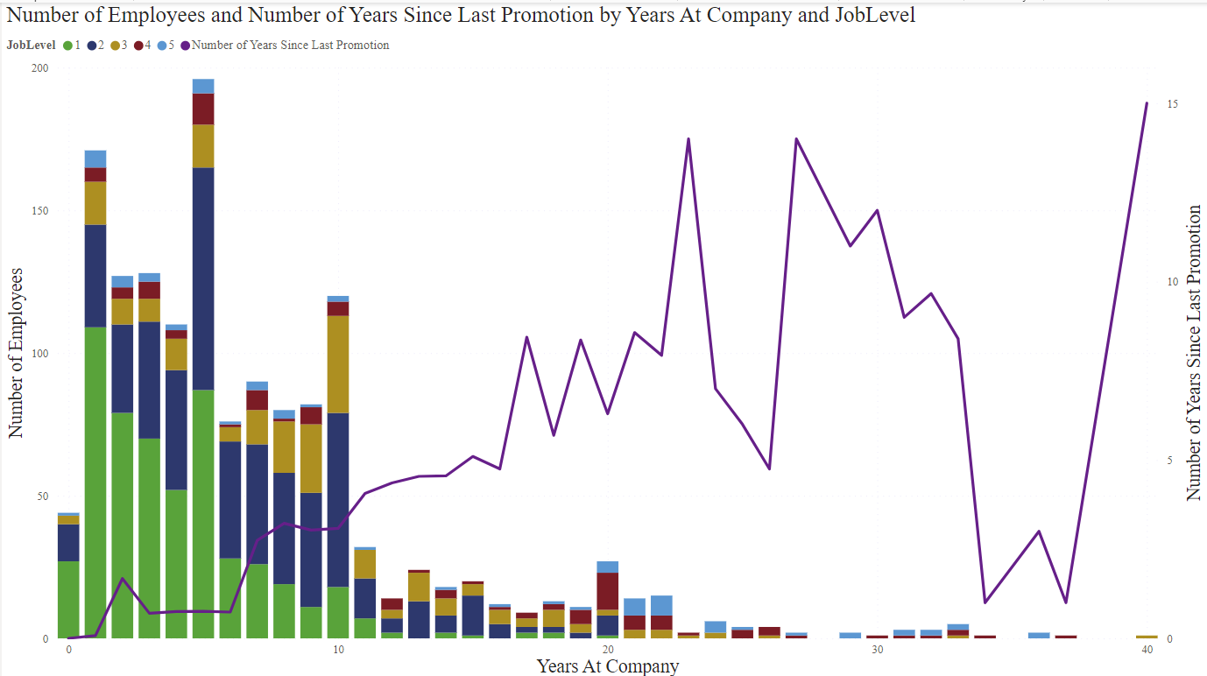

- What job levels have regular overtime hours? Ans: JobLevels 1 and 3
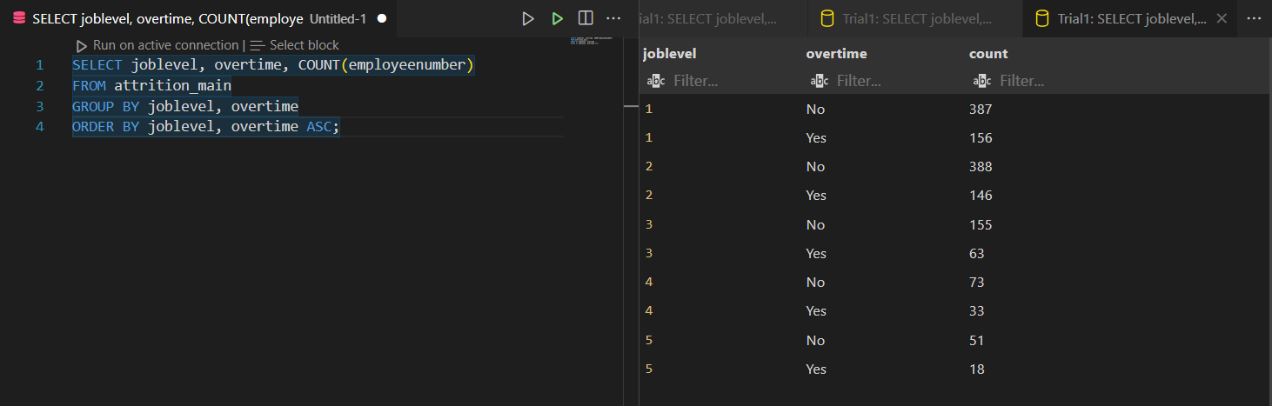
- What is the age distribution of the company?
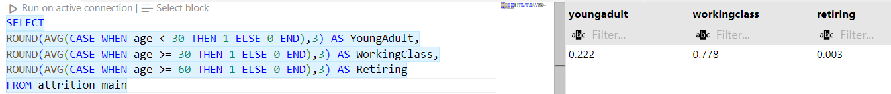
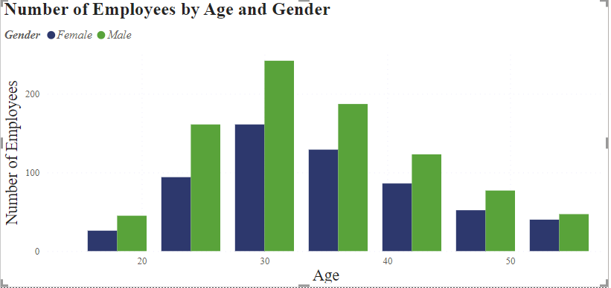
- Do younger people have a higher tendency to stay in the company? Ans: Young people have a 72% chance of staying in the company.
